IT5512- WEB TECHNOLOGY LAB-SESSION-6
DATE: 11/10/2021
NAME: A.S. PRUTHIEV
REG NO.2019506067
ANDROID LOCATION BASED APPLICATION USING JAVA ANDROID STUDIO
1)AIM:
To write a Java Program to display the longitude and latitude of the selected place
PROGRAM CODE:
MainAcitivity.java:
package com.example.myapplication;

import androidx.appcompat.app.AppCompatActivity;
import androidx.core.app.ActivityCompat;
import android.Manifest;
import android.content.pm.PackageManager;
import android.os.Bundle;
import android.view.View;
import android.widget.Button;
import android.widget.Toast;

public class MainActivity extends AppCompatActivity {

Button btnShowLocation;
private static final int REQUEST_CODE_PERMISSION = 2;
String mPermission = Manifest.permission.ACCESS_FINE_LOCATION;

// GPSTracker class
GPSTracker gps;
@Override
protected void onCreate(Bundle savedInstanceState) {
super.onCreate(savedInstanceState);
setContentView(R.layout.activity_main);
try {
if (ActivityCompat.checkSelfPermission(this, mPermission)
!= PackageManager.PERMISSION_GRANTED) {

ActivityCompat.requestPermissions(this, new String[]{mPermission},
REQUEST_CODE_PERMISSION);

// If any permission above not allowed by user, this condition will
//execute every time, else your else part will work
}
} catch (Exception e) {
e.printStackTrace();
}
btnShowLocation = (Button) findViewById(R.id.button);

// show location button click event
btnShowLocation.setOnClickListener(new View.OnClickListener() {

@Override
public void onClick(View arg0) {
// create class object
gps = new GPSTracker(MainActivity.this);

// check if GPS enabled
if(gps.canGetLocation()){

double latitude = gps.getLatitude();
double longitude = gps.getLongitude();

// \n is for new line
Toast.makeText(getApplicationContext(), "Your Location is - \nLat: "
+ latitude + "\nLong: " + longitude, Toast.LENGTH_LONG).show();
}else{
// can't get location
// GPS or Network is not enabled
// Ask user to enable GPS/network in settings
gps.showSettingsAlert();
}

}
});
}
}

GPSTracker.java:
package com.example.myapplication;

import android.annotation.SuppressLint;
import android.app.AlertDialog;
import android.app.Service;
import android.content.Context;
import android.content.DialogInterface;
import android.content.Intent;
import android.location.Location;
import android.location.LocationListener;
import android.location.LocationManager;
import android.os.Bundle;
import android.os.IBinder;
import android.provider.Settings;
import android.util.Log;

public class GPSTracker extends Service implements LocationListener {

private final Context mContext;

// flag for GPS status
boolean isGPSEnabled = false;

// flag for network status
boolean isNetworkEnabled = false;

// flag for GPS status
boolean canGetLocation = false;

Location location; // location
double latitude; // latitude
double longitude; // longitude

// The minimum distance to change Updates in meters
private static final long MIN_DISTANCE_CHANGE_FOR_UPDATES = 10; // 10 meters

// The minimum time between updates in milliseconds
private static final long MIN_TIME_BW_UPDATES = 1000 * 60 * 1; // 1 minute

// Declaring a Location Manager
protected LocationManager locationManager;

public GPSTracker(Context context) {
this.mContext = context;
getLocation();
}

@SuppressLint("MissingPermission")
public Location getLocation() {
try {
locationManager = (LocationManager) mContext.getSystemService(LOCATION_SERVICE);

// getting GPS status
isGPSEnabled = locationManager.isProviderEnabled(LocationManager.GPS_PROVIDER);

// getting network status
isNetworkEnabled = locationManager
.isProviderEnabled(LocationManager.NETWORK_PROVIDER);

if (!isGPSEnabled && !isNetworkEnabled) {
// no network provider is enabled
} else {
this.canGetLocation = true;
// First get location from Network Provider
if (isNetworkEnabled) {
locationManager.requestLocationUpdates(
LocationManager.NETWORK_PROVIDER,
MIN_TIME_BW_UPDATES,
MIN_DISTANCE_CHANGE_FOR_UPDATES, this);

Log.d("Network", "Network");
if (locationManager != null) {
location = locationManager
.getLastKnownLocation(LocationManager.NETWORK_PROVIDER);

if (location != null) {
latitude = location.getLatitude();
longitude = location.getLongitude();
}
}
}

// if GPS Enabled get lat/long using GPS Services
if (isGPSEnabled) {
if (location == null) {
locationManager.requestLocationUpdates(
LocationManager.GPS_PROVIDER,
MIN_TIME_BW_UPDATES,
MIN_DISTANCE_CHANGE_FOR_UPDATES, this);

Log.d("GPS Enabled", "GPS Enabled");
if (locationManager != null) {
location = locationManager
.getLastKnownLocation(LocationManager.GPS_PROVIDER);

if (location != null) {
latitude = location.getLatitude();
longitude = location.getLongitude();
}
}
}
}
}

} catch (Exception e) {
e.printStackTrace();
}

return location;
}

/**
* Stop using GPS listener
* Calling this function will stop using GPS in your app
* */

public void stopUsingGPS(){
if(locationManager != null){
locationManager.removeUpdates(GPSTracker.this);
}
}

/**
* Function to get latitude
* */

public double getLatitude(){
if(location != null){
latitude = location.getLatitude();
}

// return latitude
return latitude;
}

/**
* Function to get longitude
* */

public double getLongitude(){
if(location != null){
longitude = location.getLongitude();
}

// return longitude
return longitude;
}

/**
* Function to check GPS/wifi enabled
* @return boolean
* */

public boolean canGetLocation() {
return this.canGetLocation;
}

/**
* Function to show settings alert dialog
* On pressing Settings button will lauch Settings Options
* */

public void showSettingsAlert(){
AlertDialog.Builder alertDialog = new AlertDialog.Builder(mContext);

// Setting Dialog Title
alertDialog.setTitle("GPS is settings");

// Setting Dialog Message
alertDialog.setMessage("GPS is not enabled. Do you want to go to settings menu?");

// On pressing Settings button
alertDialog.setPositiveButton("Settings", new DialogInterface.OnClickListener() {
public void onClick(DialogInterface dialog,int which) {
Intent intent = new Intent(Settings.ACTION_LOCATION_SOURCE_SETTINGS);
mContext.startActivity(intent);
}
});

// on pressing cancel button
alertDialog.setNegativeButton("Cancel", new DialogInterface.OnClickListener() {
public void onClick(DialogInterface dialog, int which) {
dialog.cancel();
}
});

// Showing Alert Message
alertDialog.show();
}

@Override
public void onLocationChanged(Location location) {
}

@Override
public void onProviderDisabled(String provider) {
}

@Override
public void onProviderEnabled(String provider) {
}

@Override
public void onStatusChanged(String provider, int status, Bundle extras) {
}

@Override
public IBinder onBind(Intent arg0) {
return null;
}
}
Activity_main.xml
<?xml version = "1.0" encoding = "utf-8"?>
<LinearLayout xmlns:android = "http://schemas.android.com/apk/res/android"
android:layout_width = "fill_parent"
android:layout_height = "fill_parent"
android:orientation = "vertical" >

<Button
android:id = "@+id/button"
android:layout_width = "fill_parent"
android:layout_height = "wrap_content"
android:text = "getlocation"/>

</LinearLayout>
Strings.xml
<?xml version = "1.0" encoding = "utf-8"?>
<resources>
<string name = "app_name">Pruthiev Location App</string>
</resources>

AndroidManifest.xml:

<?xml version="1.0" encoding="utf-8"?>
<manifest xmlns:android="http://schemas.android.com/apk/res/android"
xmlns:tools="http://schemas.android.com/tools"
package="com.example.myapplication">

<uses-permission android:name="android.permission.ACCESS_FINE_LOCATION" />
<uses-permission android:name="android.permission.ACCESS_COARSE_LOCATION"/>
<uses-permission android:name="android.permission.INTERNET" />
<application
android:allowBackup="true"
android:icon="@mipmap/ic_launcher"
android:label="@string/app_name"
android:roundIcon="@mipmap/ic_launcher_round"
android:supportsRtl="true"
android:theme="@style/Theme.MyApplication">
<activity
android:name=".MainActivity"
android:exported="true">
<intent-filter>
<action android:name="android.intent.action.MAIN" />

<category android:name="android.intent.category.LAUNCHER" />
</intent-filter>
</activity>
</application>

</manifest>

OUTPUT:
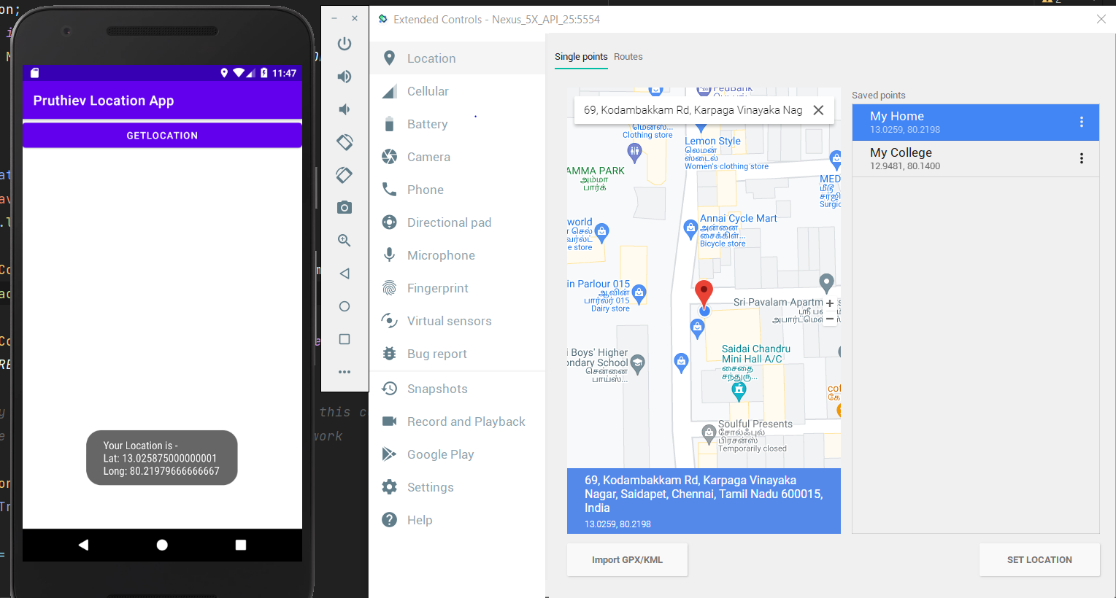

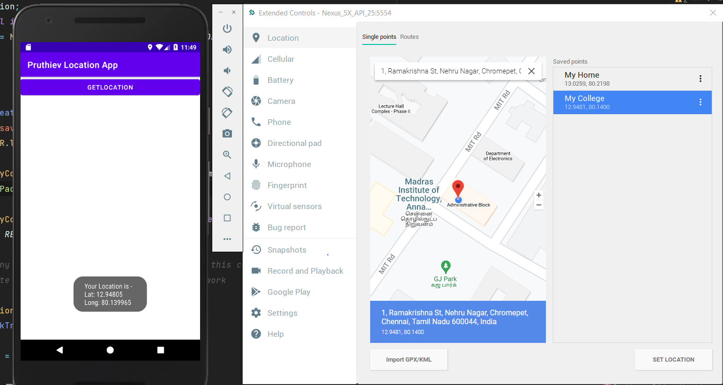

RESULT :
Thus a Andoid location based Application is created using java(Android Studio) and executed successfully.

